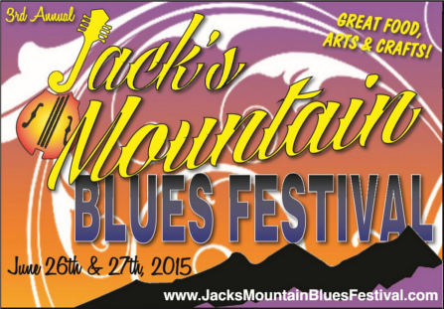

Please email your product line to us for approval prior to submitting this form. Thank you.

jacksmountainbluesfestival1@gmail.com

Vendor Registration
Friday, June 26, 2015 - Noon-11 PM & Saturday, June 27, 2015 - 9 AM–11 PM

Below is a list of conditions that are to be observed by the participating vendors of The Jack’s Mountain Blues Festival 2015:
1. The festival will be held rain or shine. Setup can begin Noon Friday, June 26, 2015. Vehicles must be removed from the festival one-half hour before starting time and must remain out of the festival area until ending time.
2. Jack’s Mountain Blues Festival, Jack’s Mountain Blues Festival Officers, Committee and Sponsors will not be responsible for theft, accidents or loss or damage to property belonging to vendors.
3. Pricing restrictions: Food vendors must display prices.
4. Vendors shall indemnify and hold harmless Jack’s Mountain Blues Festival, Jack’s Mountain Blues Festival Officers, Committee and Sponsors from any and all claims and damages including attorney’s fees and court cost for personal injury, loss or damage to property caused by or due to the acts of omissions of the vendors.
5. Vendors must supply their own tent, table and chairs.
6. Please do not overload the electrical outlets, only one appliance per plug. Multiple cords and power strips are forbidden.
8. All decisions of the Jack’s Mountain Blues Festival Committee are final.
9. No Refund for No Shows (or within 30 days of the event)

Please complete the information below and return along with your payment to:
Jack’s Mountain Blues Festival
PO Box 255
Mifflinburg, PA 17844
(570) 452-0088 or (570) 765-9249

Checks should be made payable to Jack’s Mountain Blues Festival

Name of Business/Organization___________________________________________________________________________
Contact Person________________________________________________Phone____________________________ Street_________________________________________City____________________________________________State__________________Zip________________________Cell Phone____________________________________
E-Mail__________________________________________

Type of Vendor (check one)
( ) Promotional: advertising, promoting, or educating ( ) Food: selling food or a service
( ) Crafts: selling handmade or retail items ( ) Other:__________________________________________

**FOOD VENDORS must have a copy of your SERVSAFE certification. **

Specify Items for Sale___________________________________________________________________
*FOOD VENDORS ONLY: Item pricing range_________________________________________________ _____________________________________________________________________________________
_____________________________________________________________________________________

Vendor Fees:
One 10’ x 12’ Space Friday & Saturday – Purchase of Festival ticket @ $25 for each attending vendor and associate.

Number Of Attending Personnel@$25 Each: _______

Number Of Days Attending Festival (check all that apply) ( ) Friday ( ) Saturday

How many Spaces Do You Need? (10’x12’) _____________ (include tent stakes, awning, hitches,)
Do you have a ( ) Trailer ( ) Tent ( ) Other Size______________________________ (including hitches, tanks, awnings, etc.)

DO YOU REQUIRE ELECTRICITY? $35 Hook-up Fee. Yes_____ No_____

Do you have a Generator? Yes_____ No_____
How Many 110 Plugs? ______ How Many 220 Plugs? ________

Total Vendor Fees Enclosed (including Electrical Hook-Up) $_________

Signature ________________________________________________________ Date_______________________
Jack’s Mountain Blues Festival Officer______________________________________________________

